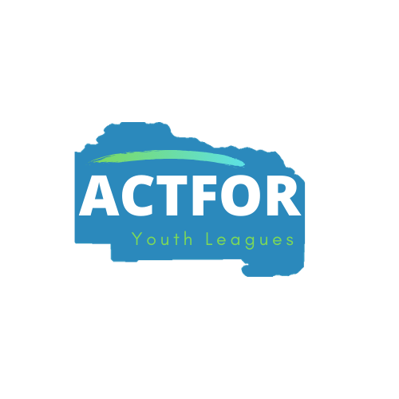
COVID-19 Disclosure, Acknowledgement & Waiver
COVID-19 has been declared a worldwide pandemic by the World Health Organization. COVID-19 is extremely contagious and believed to spread from person-to-person contact. Federal, state, and local governments and health agencies recommend social distancing and have, in many areas, prohibited group activities.
ACTFOR is taking steps to reduce the spread of COVID-19; however, ACTFOR cannot guarantee that you or your child(ren) will not become infected with COVID-19. Further, attending ACTFOR activity could increase the risk of contracting COVID-19.
By signing this agreement, I acknowledge the contagious nature of COVID-19 and voluntarily assume the risk that my child(ren) and I may be exposed to or infected by COVID-19 by attending ACTFOR activity and that such exposure or infection may result in personal injury, illness, permanent disability, and death. I understand that the risk of becoming exposed or infected by COVID-19 may result from the act, omission, or negligence of myself and others, including, but not limited to, ACTFOR volunteers, and other participants and their families.
I voluntarily agree to assume the foregoing risks and accept sole responsibility for any injury to my child(ren) or myself (including, but not limited to personal injury, disability, and death), illness damage, loss, claim, liability, or expense, of any kind, that I or my child(ren) may incur by reason of ACTFOR activity (“Claims”). On my behalf of my child(ren), I hereby release and covenant not to sue ACTFOR, its affiliated organizations, employees, volunteers, agents, and representatives, of any liability from the Claims.

Duty to Inform
_____I will inform you If I encounter someone who tested positive within 14 days prior.
_____I will inform you and not attend ACTFOR activities for 14 days if I develop any symptoms.
_____If I test positive for COVID-19, I will not return to ACTFOR activity without medical clearance.

Signatures
Participant Name:__________________________________________________
Parent/Guardian Name: _____________________________________________
Participant/Guardian Signature: _______________________________________
Date:_____________________________________________________________

